## Thermal Analysis

In this part thermal analysis of the main switching devices, two paralleled MOSFETs and the output diode, are discussed. For all switching devices OZDAS0003EPL25 aluminum heatsink given in Figure … is used.

Figure 1 OZDAS0003EPL25 Aluminum Heatsink

All main switching devices show the same thermal lumped parameter circuit behavior given in Figure …

Figure 2 Thermal Lumped Parameter Circuit

The junction temperature of the semiconductor devices can be written as follows:

$$Tjunction=Tambient+Ploss (RJC+RCH+RHA)$$

Thermal resistance from heatsink to ambient temperature is 7.5 °C/W for OZDAS0003EPL25 aluminum heatsink. The ambient temperature is taken as 30 °C since the demo is conducted in summer. Junction to case and case to heatsink thermal resistances, maximum power loss on the semiconductor devices observed in the simulation and settling junction temperature according to the formula given above are tabulated in Table …

|  |  |  |  |  |
| --- | --- | --- | --- | --- |
| **Switching Device** | **RJC (°C/W)** | **RJC (°C/W)** | **Ploss (W)** | **TJ (°C)** |
| MOSFET | 1.05 | 0.5 | 1.52 | 44 |
| DIODE | 1.7 | 0.5 | 3.13 | 61 |

Table 1 Thermal Analysis According to Simulations

Although these results do not require any type of cooling system, in real testing MOSFET temperature is observed to exceed 100 °C. Next, oscilloscope probes are utilized to measure switch current and voltage. The power loss on the MOSFET measured as 7.5 Watts by the MATH and mean functions of the oscilloscopes as mentioned in Test Results Section. According to this measurement and lumped parameter approach MOSFET junction temperature is calculated as 96 °C which is unacceptable. Therefore, a fan is used to cool down the switching devices. In the last design MOSFET operates at 63.6 °C which is shown in Figure …

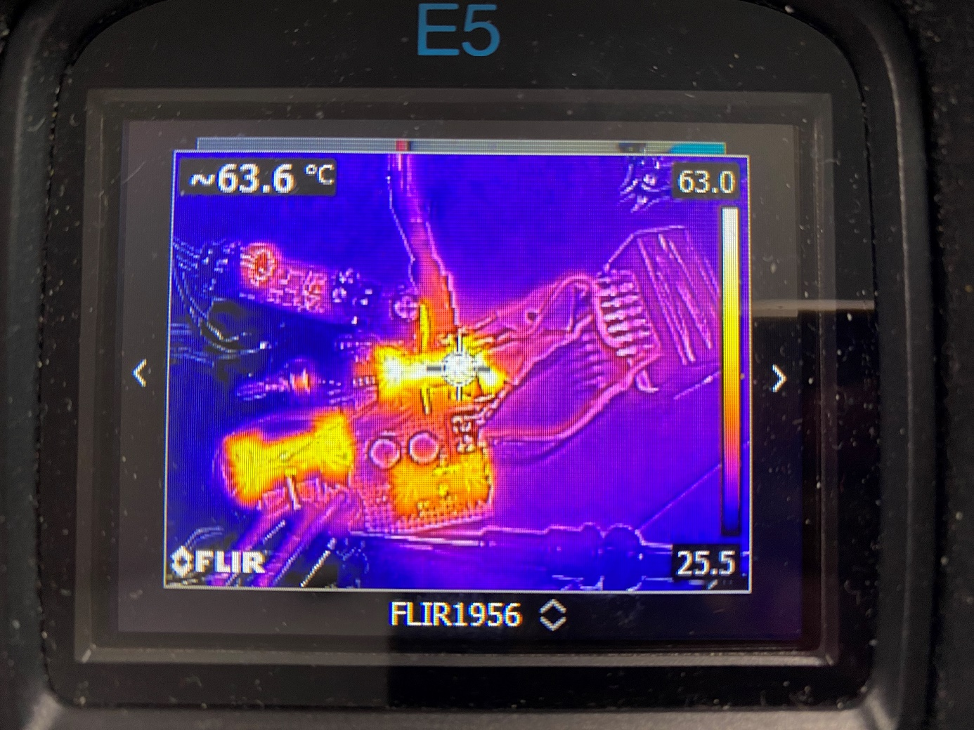

Figure 3 Thermal Photograph of the Converter

## Cost and Sizing

The size of the product is 2000cm3. The dimensions are 10x10x20 cm where 20cm is the height of the converter while 10cm is the width and length of the converter.

The cost analysis of the converter can be found in Table…

Table 2. Cost analysis

|  |  |
| --- | --- |
| **Component** | **Price** |
| 2xE Magnetic Core | 156.18 TL |
| 2x IRFU3710ZPbF | 180,82 TL |
| UC3845AN | 19,6768 TL |
| 2xDSA30C100PB | 72,466 TL |
| Zener diode | 3,875 TL |
| 3x PKLH-016V471MG125 | 7,23 TL |
| 3x OZDAS0003EPL25 | 31,0866 TL |
| Stone resistor | 2,83 TL |
| 3xShielded double clemens | 20,61 TL |
| 4x15mΩ SMD resistor | 140 TL |
| 2xSRI1209-100M | 35,53 TL |
| Buck Converter | 200 TL |
| PC817X1NSZW6 | 4,45 TL |
| Fan | 15 TL |
| Transformer cable (1.8m) | 36 TL |
| KLS1-216-08 | 0,53 TL |
| Pertinaks 10x10 | 18,33 TL |
| Additional | 20 TL |
| TOTAL | 964.61 TL |

The total cost of the product is 964.61 TL, as given in the table above. It should be noted that the main factor that increased the cost is the quantity of the components. While having similar specifications, topologies with lesser component numbers, such as full-bridge converter, can be implemented at a much lesser cost.

## Conclusion

To conclude, this report information about the research, design and implementation of the EE464 term project, isolated DC-DC battery charger, in detail. In the research phase, several topologies are investigated to choose the most suitable isolated DC-DC converter topology for the given specs. The team decided on the utilization of the flyback converter topology due to its simplicity and safe operation. A flyback converter was designed and its operation was confirmed using LTSpice simulations. After some changes to the design that are decided upon in the feedback session, the topology has been implemented. Following the implementation, some unforeseen situations have arisen and discrepancies in the operation of the converter from the simulation have been identified. Due to unpredictable conditions, heating up of the converter, mainly MOSFET, became a problem. To solve this problem a cooling fan and a parallel MOSFET that will share the current with the original MOSFET have been implemented. On the demonstration day, we demonstrated the line regulation, the quickness of response time of the system, rated values, behavior during sudden load turn on/off and battery charging capability of the converter. Moreover, a datasheet was prepared and given to people who were there on the demonstration day. The addition of the fan along with the unpredicted MOSFET parameters caused a difference between the expected efficiency and the measured efficiency which is the only project specification the converter could not meet. Overall, we learned so many practical power electronics knowledge, implemented hardware and we believe that we have successfully completed the project.